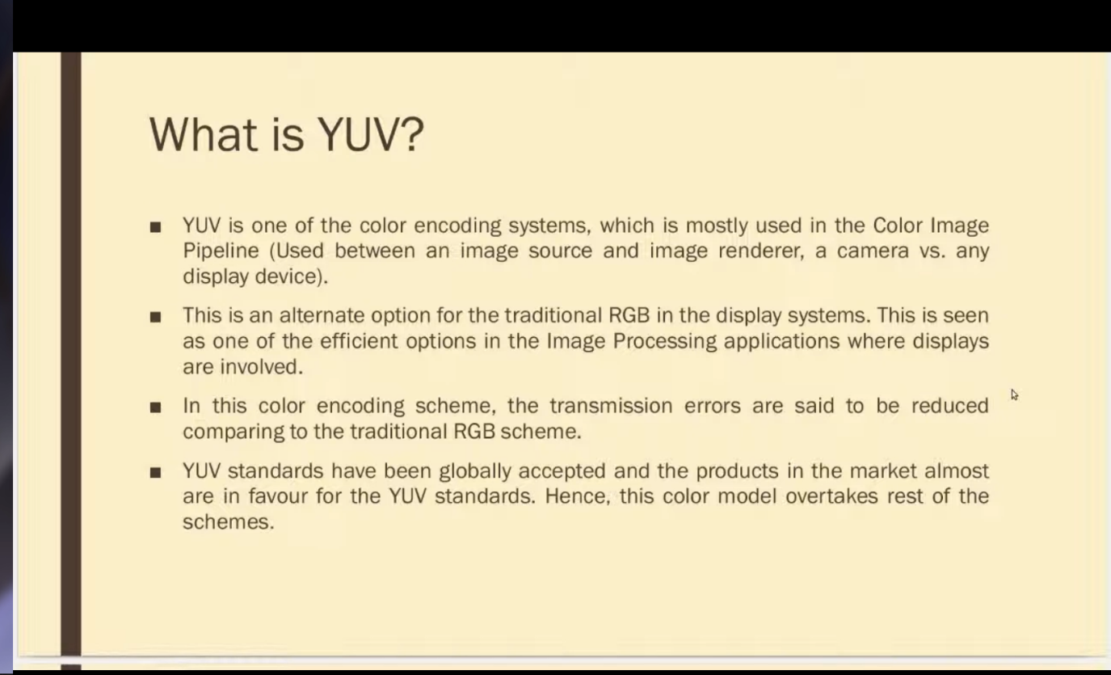

HOW NETTER THAN RGB

POINT 4 AND ALSO REDUCED BADNWIDTH USAGE

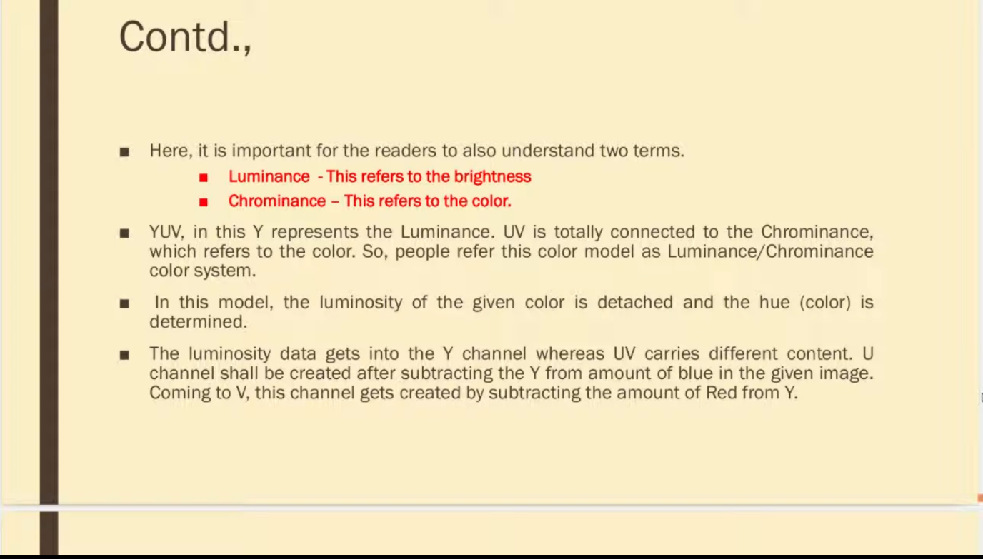

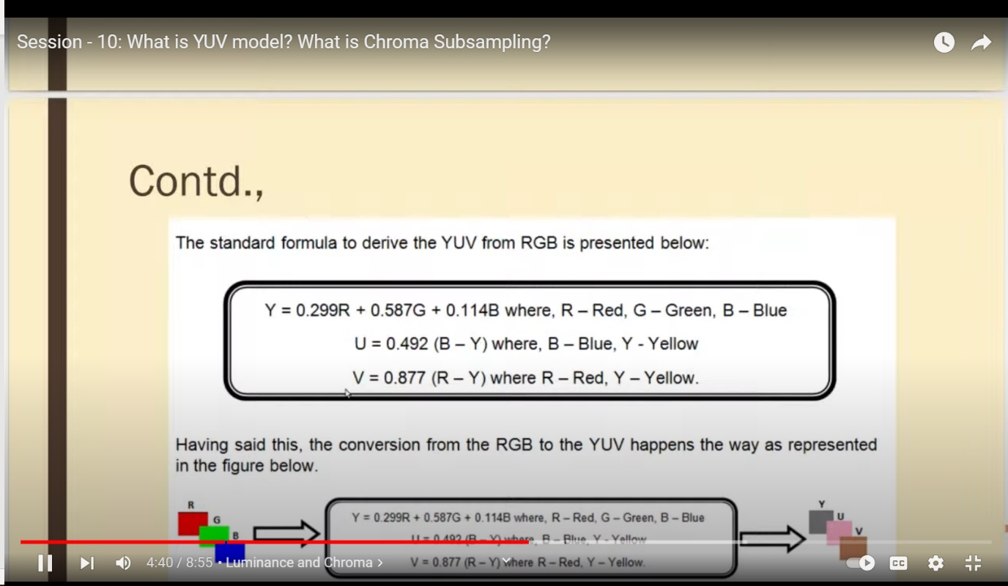

encode:

Here we simply change the rate of an complex oscillator according to the Y, U and V values we get from the input image and only use the real part of the oscillator as output.

decode:

FM demodulation is not so easy. After many frustrating attempts to emulate hardware and playing around with zero cross detection and Phase-locked loop detectors i finally found a very nice way to do it:

Using Hilbert Transformation we get a complex valued function from a real valued function, which we differentiate in time using polar coordinates and getting the instantaneous frequency from the argument.

Doing Hilbert Transform in discrete space for this purpose is also know as Digital Down Conversion.

my DDC consists of an complex valued decimating ideal fir filter using Kaiser window at its input and an complex oscillator mixer at its output.

Ddc - digital down-converter converts a digitized, band-limited signal to a lower frequency signal at a lower sampling rate in order to simplify the subsequent radio stages. The process can preserve all the information in the frequency band of interest of the original signal

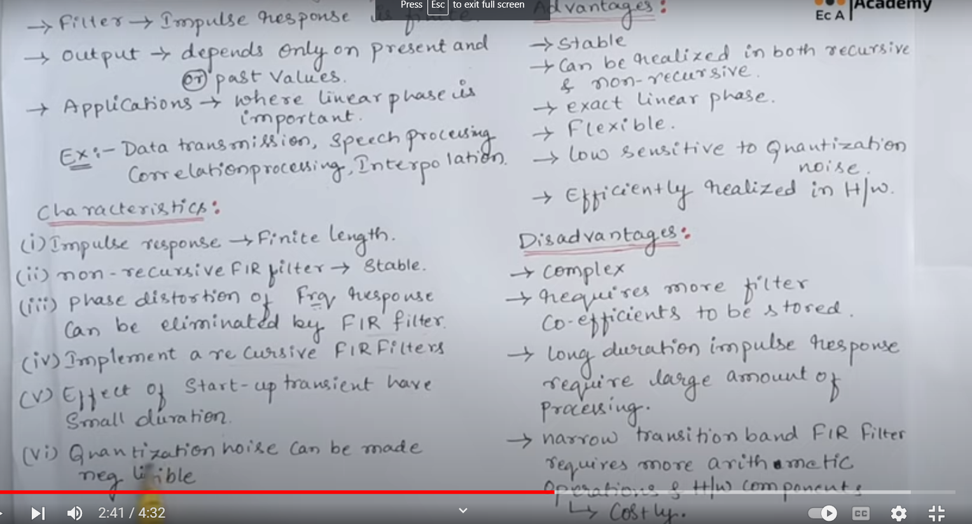

We use udp based which just broadcasts info instead of tcp which takes a 3-way handshake , nd creates latency, which we cant afford in the sound comms

Encryption technique is going to be PGP(pretty good privacy), which we used as it can suffer data corruption, unlike other asymwetic techniques, like rsa which cant suffer data corruption, as it permutates 64 bit data , nd then makes left and right chunks, so if one data is corrupted the whole data may get corrupted

In pgp however if some packets r corrupted then they r dropped, nd garbage values r creqated which woibnt be transmitted at all

Human inutuion is good enough to make meaningful data even out of corrupted data ( walkie talkie army people, static), but computers cant do it, so we use pgp



